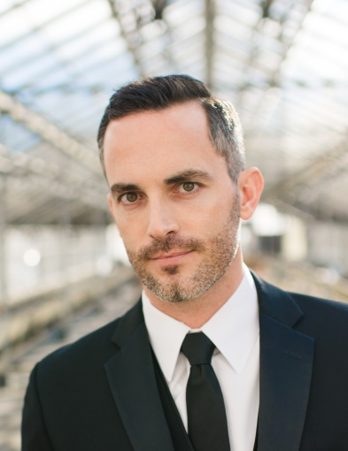
Adam F. Say
Director of International Sales
RoomMates Décor, a division of York Wallcoverings, Inc.

Mr. Say has a unique and varied international background including expertise in logistics, sales, licensing and distribution. He serves as Vice Chair of the World Trade Center Harrisburg, and received his MBA from Eastern University.

